Lesson 4 Demo 3: Polling SCM

This section will guide you to:

* Schedule a freestyle build job in Jenkins that polls the SCM every night

This lab has two sub-sections, namely:

1. Scheduling a build job to poll an SCM and run Maven build steps

2. Testing a scheduled build

**Step 1:** Scheduling a build job to poll an SCM and run Maven build steps

* Go to Jenkins **dashboard**
* Click on ***New Item***
* Enter a **name** for your project
* Select ***Freestyle project*** as the build job type

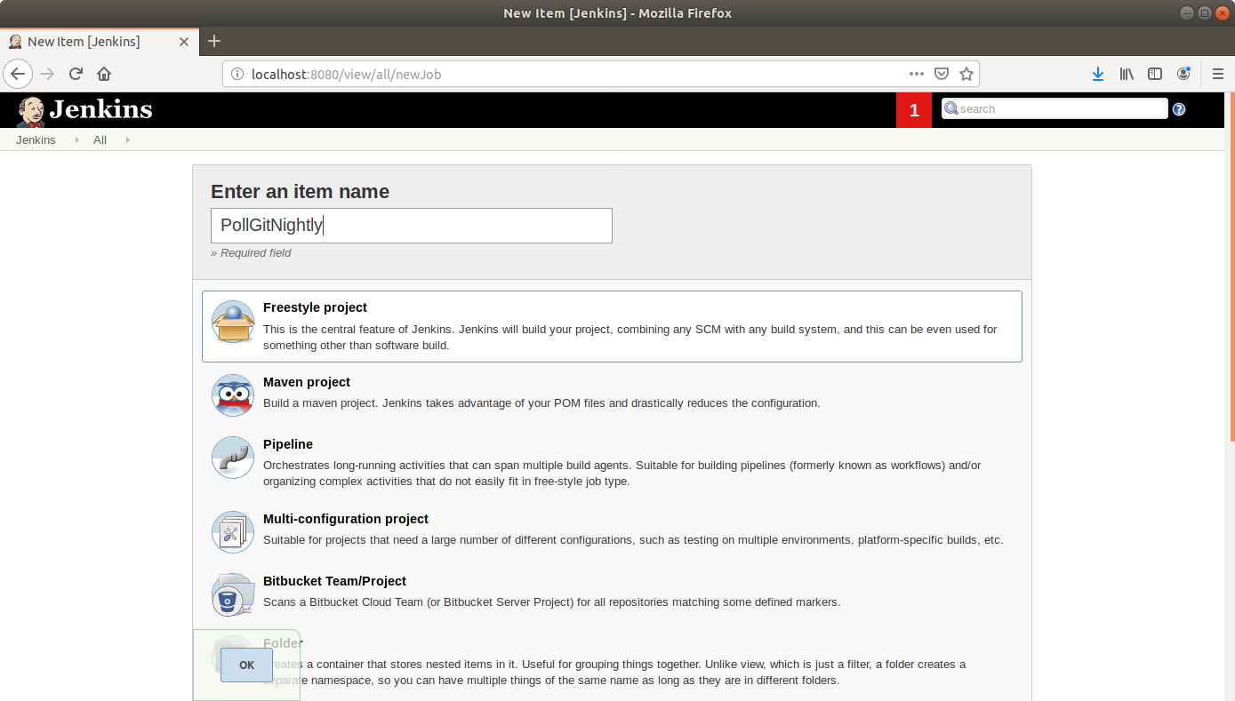

* Click **OK**
* Enter job details like **description**

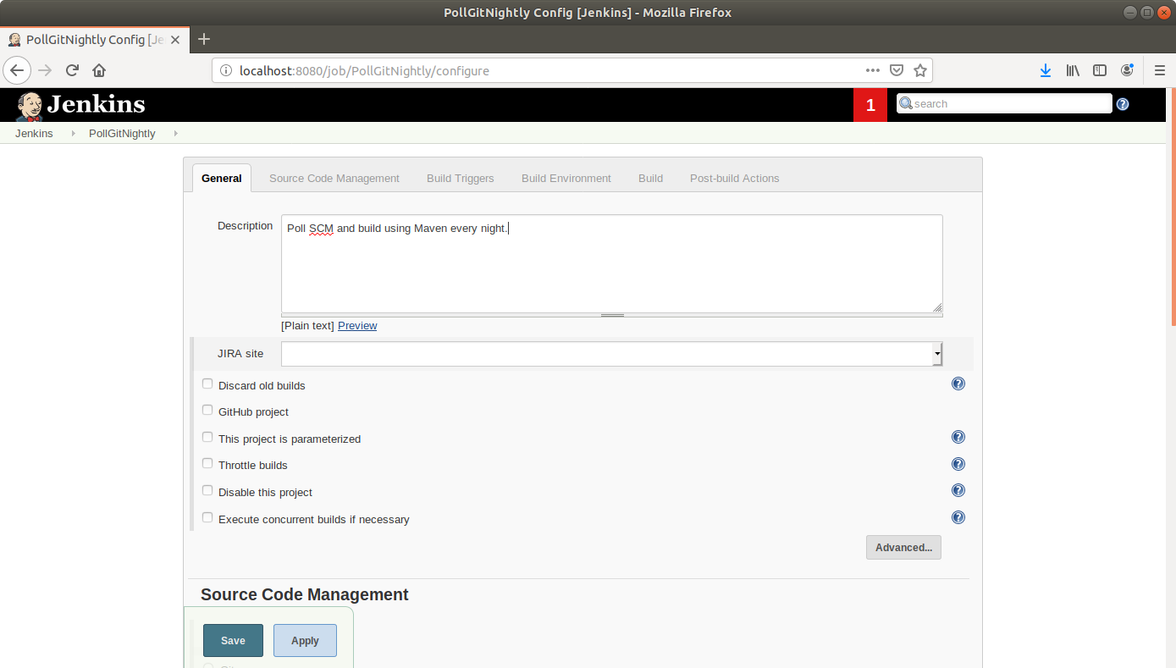

* Scroll down to the **Source Code Management** section and select ***Git***.
* Enter the link to the repository in the field that appears.

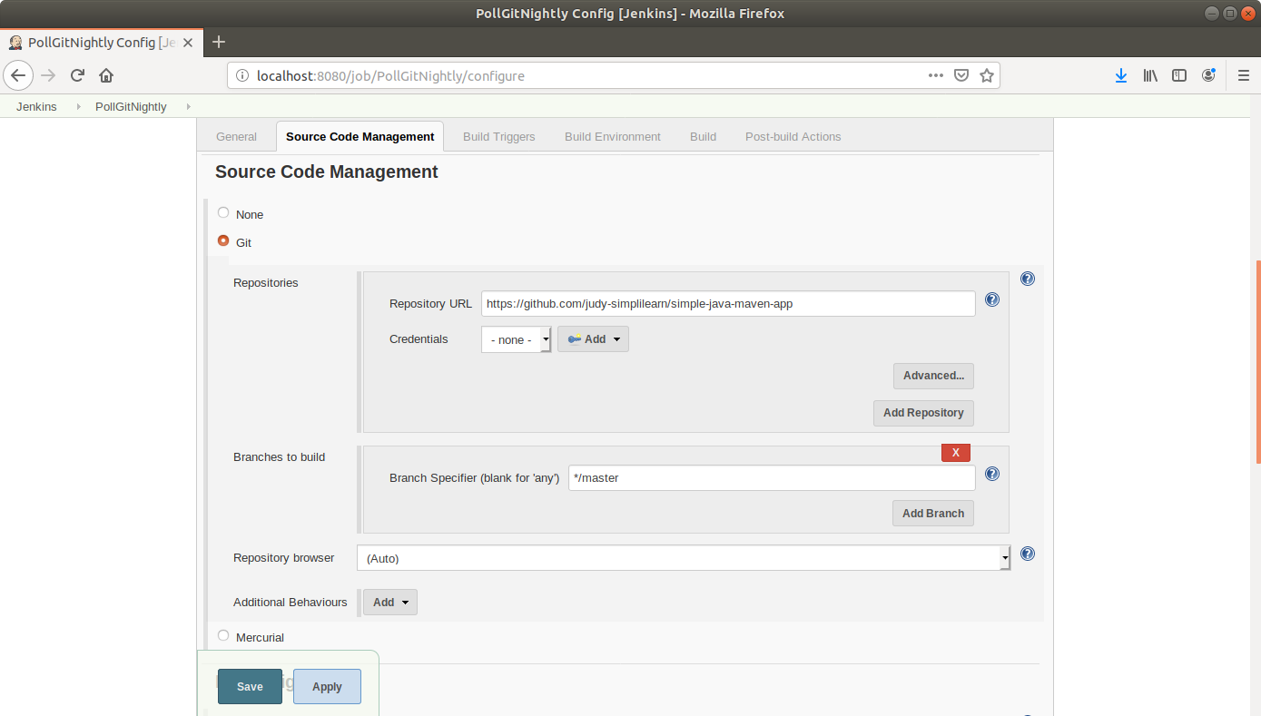

* Scroll down to the ***Build Triggers*** section and select the ***Poll SCM*** option.
* In the box that appears, enter the cron syntax to schedule a build every night at 12. (ie) **0 0 * * \***

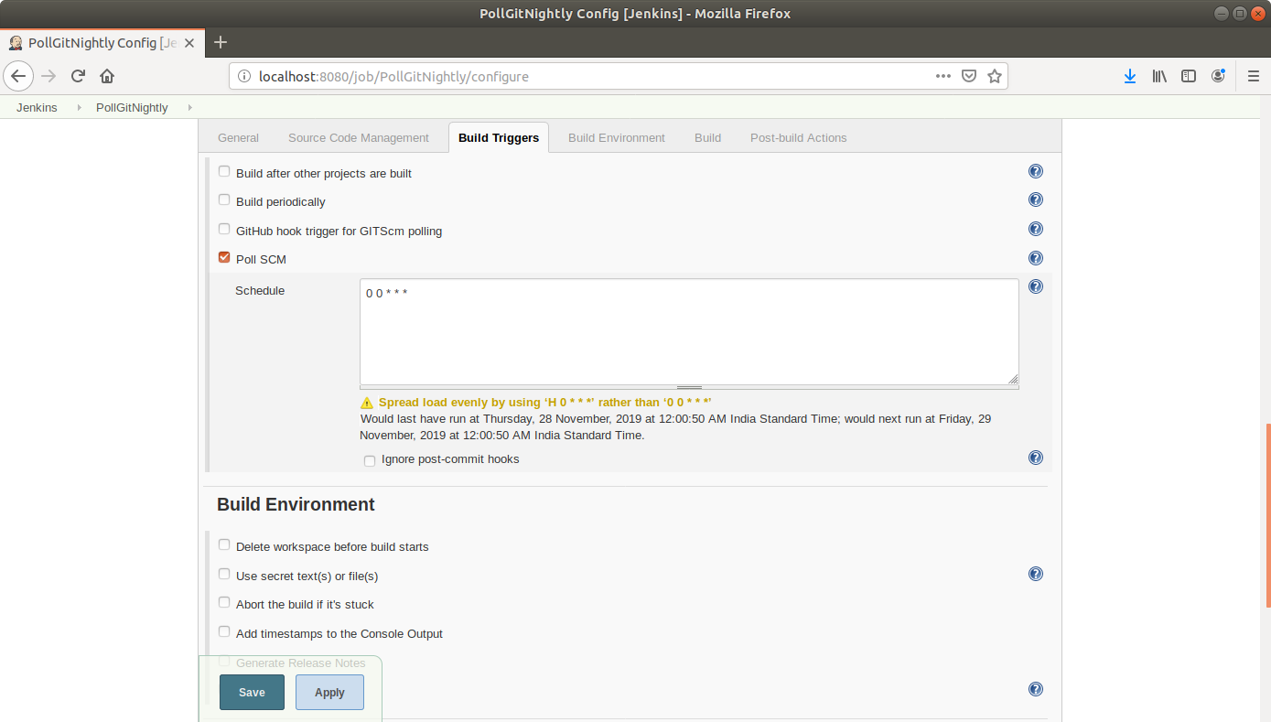

* Scroll down to the *Build* section and click on ***Add build step*.**
* Select ***Execute Shell***from the drop down that appears.
* Enter the following maven command in the textbox that appears:  
  **mvn clean install**

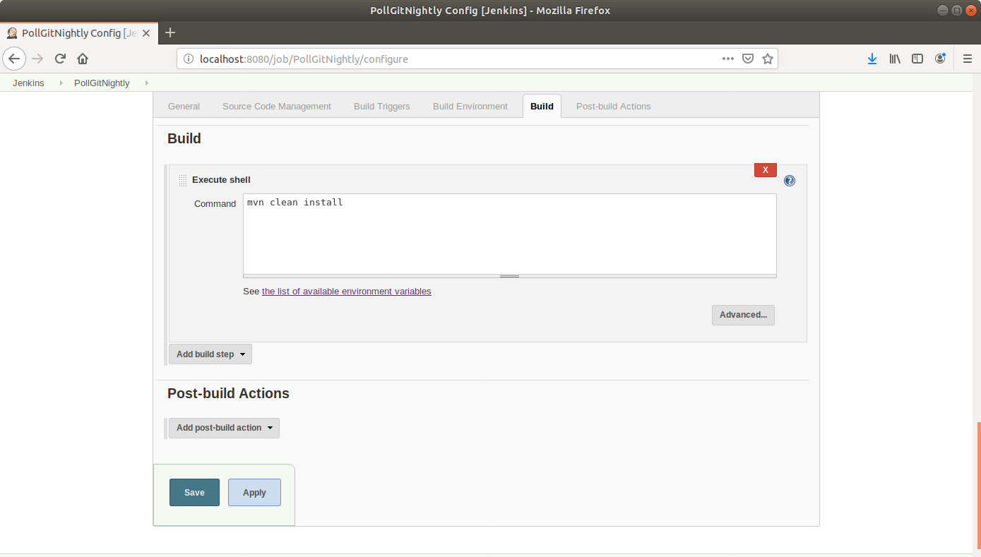

* Click Save.

**Step 2:** Testing a scheduled build

* Click on the project name in the Jenkins dashboard.
* Click ***Build Now*** in the project window to make sure the build works. Jenkins will now build your project.
* Click on the ***Build History***to view the build results.
* Click on the ***Console Output*** to view the build logs.

